Mission Statement
Adventures For The Cure (AFC) is a 501 (c)(3) tax-exempt nonprofit organization that exists to raise awareness for Diabetes, to show those diagnosed with Diabetes and their families how leading a healthy and active lifestyle can move you beyond your perceived limits, and to raise funds for Diabetes research. Our organization also raises awareness and funds for other causes that the board of directors has selected. In the past we have raised funds for the following organizations:

* American Diabetes Association
* Kupenda For The Children
* Blood:Water Mission
* Juvenile Diabetes Research Foundation
* Partners Seeking a Cure

The organization has also set out to inspire others to live healthy lifestyles and to adventure beyond their perceived limits, because “ANYTH!NG is possible!”

What We Have Done

AFC was started in 2005 by Adam Driscoll and Patrick Blair. We were best friends from college where we met on the Division 1 UMBC Track/Field and Cross Country team. After college was over, in 2005, we both found good, stable jobs, but we felt like something was missing. We wanted to do something more to help others and to really try make a difference in the world. Since Adam has Type 1 Diabetes, and because we both loved to bike and run, we decided to put on a charity bike ride of 320 miles in 2 days to raise money for the American Diabetes Association (ADA). We successfully raised $7,000.00 and Adventures For the Cure had begun!


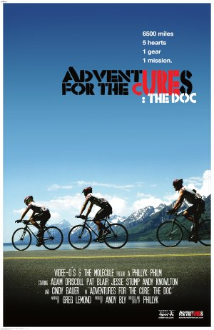
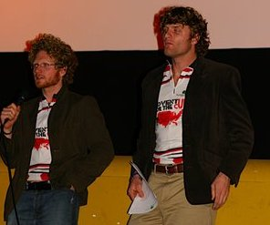
Due to the success of our 2005 “adventure”, we decided to put on yearly fundraising events for good causes. In 2006, we were joined by another friend from college, Jesse Stump, in a 6,500 mile, single speed fixed gear, charity bike ride across the country. We traveled west to east and we raised about $12,000 for ADA and $27,000 for an organization called Kupenda for the Children. Kupenda helps children with disabilities in Kenya. During our 2006 Cross Country adventure, our friend PHillyK, shot and produced a documentary video of our exploits. The video was narrated by Greg Lemond, won the People's Choice award at the Beloit International Film Festival in Wisconsin, and has received an overwhelmingly positive response. It is just another tool in our arsenal that we use to talk about Diabetes and charity works.

In 2007, we put on a local 5k in Baltimore, MD to raise money for Blood:Water Mission, an organization that builds clean water wells in Africa. In 2008, we were joined by Alex Driscoll and Keith Rohr in a 4-person Race Across America (RAAM) team. We raced on single speed fixed gear bikes. We placed 5th out of 27 4-person teams and raised about $17,000 for ADA and Partners Seeking a Cure (PSC).

We also consider ourselves to be motivational speakers. We have given numerous talks at diabetes support groups, summer camps for young diabetics, churches, boy scouts, triathlon/cycling clubs, rotary clubs, college classes, etc. We are so happy when we hear of someone who, because they saw what we are doing, decides to go out and use their gifts/talents to make a difference!

Future Plans

This year's RAAM was a total and complete success. We rode Fixed Surly Steamrollers (22 lb.), yet we were able to keep an average speed of 19.15 mph for the entire trip. This race is a true adventure; it labels itself as the “World’s Toughest Bike Race”!
Next year's RAAM we will be riding as a 2 man team. We plan to ride on bikes that are comparable to that of our competition (with gears), and we plan on winning! We scoped out the 2 man competition this year and if we train hard we know that we can win next year. We are also vying for the 2 man record of 19.58 mph average, set in 2006. It can/will be done!

Our 2009 RAAM training has already begun. We will start with biking about 40 miles per day during the week and long rides on both Saturday and Sunday. We will increase our weekly mileage from there. In 2008 we did not start our serious training until about 3 months before the trip. In 2009, we will be training for about 11 months.

Cannondale’s Investment

Princeton Sports has been a great help to our organization in every way, ever since we went to them and asked for their help in preparing for our 2006 cross country charity adventure. They believe in us and in our cause(s). We have brought new customers to their store. We have increased their business exposure locally and throughout the country. They can rest assured that, while we are out there “doing our thing”, they have only received positive exposure from our actions. We strive to be role models to younger children, as well as adults, by acting and living appropriately.


As a sponsor, you will be helping us to help others. We hope to bring even greater exposure to Kupenda for the Children and helping those in need, as well as the horrible disease that is Diabetes by winning RAAM. We will be doing much of our own promoting and marketing. Through our many adventures and years of charity work, we are learning how to be more effective at marketing ourselves. We believe that getting information out about what we are doing is key to fulfilling our Mission Statement.

Cannondale will also be able to benefit from our efforts by showcasing the superior performance of its bikes and brand. Cannondale will end up with a winning 2 man Race Across America (The World’s Toughest Bike Race) team and possibly the new record holders in the division. We currently have almost 1,000 people on our email list and we are becoming well-known in the Baltimore/Washington D.C. metro area for our charitable and athletic efforts.

Please know that we would also like our relationship with your company to be a two way street. Knowing what you expect from us will assist us in meeting your goals to the best of our abilities.

Adventures for The Cure’s Request

As previously stated, we competed on single speed fixed gear bikes in RAAM this past year. Those bikes were provided to us by Surly Bikes. While we have an extremely good relationship with that company, we have decided to explore other options because Surly bikes are just not designed for racing.

By studying the winning teams of this year’s RAAM, we learned that most teams have 2 bikes per rider. This serves a dual purpose. First, having 2 bikes means each rider has a backup bike in case one of his bikes has a total breakdown during the race. Secondly, one of the bikes needed is a Time Trial bike for those long flat days in Kansas, while the other is a Road bike needed for the steep Rocky and Appalachian Mountains.

We are looking to partner with Cannondale. Cannondale makes some of the best Time Trial and Road bikes in the business. We are confident that we will be able to win this race using these bikes. Cannondale will stand to benefit from this marketing and media exposure. We would like to further explore marketing and media options regarding this request as our relationship progresses.

Finally, the Cannondale brand will benefit from assisting and supporting Adventures for the Cure during the race itself. RAAM requires that each team have a support crew. The job of the support crew is to ensure that the riders and the bikes are kept in racing condition. A company mechanic with Cannondale’s branded support van is a moving billboard and visible for the 3,100 miles of the race.

We hope that through a joint partnership in this venture, we will be able to enhance our mission as a non-profit, break barriers as avid bicyclists, as well as wholeheartedly increase the exposure to Cannondale, its products, and its dedication to the community.

References

Alan Davis
Princeton Sports, Owner
410-995-1894
adavis@princetonsports.com

Cindy Bauer
Kupenda for the Children, President/Founder
410-456-2311
cindykupenda@gmail.com

David McShea
American Diabetes Association, National Director
410-265-0075 x4673
DMcShea@diabetes.org

Chip Warfel
Mid Maryland Triathlon Club, President
410-402-6844
cwarfel@mprc.umaryland.edu

Charlene Riikonen
Cerasport, Owner
410-309-1000
charlene.riikonen@ceraporducts.us

Additional Information

Adventures For the Cure website:
http://adventuresforthecure.com

Documentary Movie Trailers:
http://adventuresforthecure.com/movie/trailers.php
Videos of AFC in Kenya (with Kupenda for the Children):
http://adventuresforthecure.com/kupenda_videos.php

RAAM website:
http://raamrace.org

PHillyK Videe-o's website (creator of AFC Documentary Movie):
http://www.videe-os.com

Contact Us

Patrick Blair Adam Driscoll
443-223-5740 443-823-0819
pblair12@gmail.com adrisc1@gmail.com

Photos of Adventures For The Cure
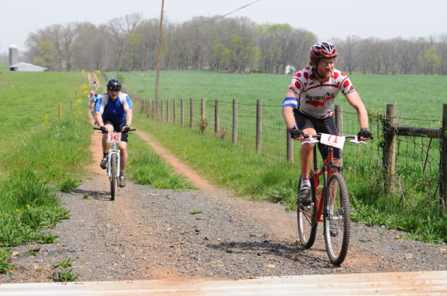
(Right: Adam, 13 hour mountain bike race)
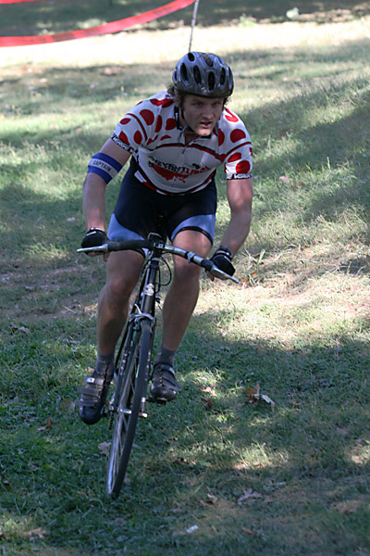
(Adam cyclocross)

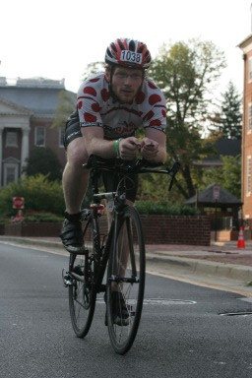
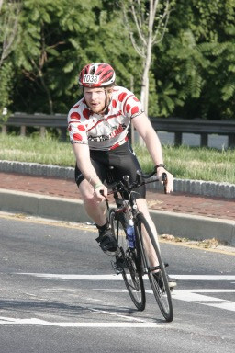

(Pat competing at a triathlon)
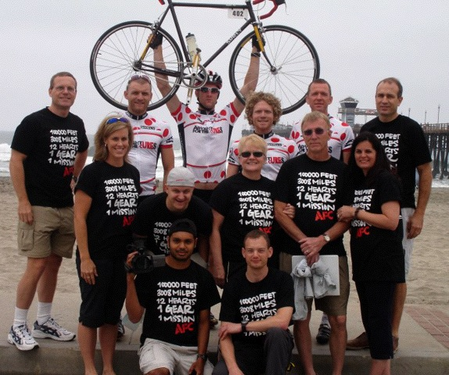
(Adventures For the Cure - RAAM Team ’08)
Press Reports on Adventures For The Cure
Velo News: Fixed gear team to take on RAAM
http://www.velonews.com/article/77026
Posted Jun. 3, 2008

The Adventures for the Cure (AFC) cycling team has entered the four-man relay category for the world’s longest bicycle race, the Race Across America, known simply as “RAAM.” This race has been called the world’s toughest bicycle race, covering over 3,000 miles from Oceanside,
CA to Annapolis, MD. The route is 1,000 miles longer than the 2008 Tour de France, and contains more than 100,000 feet of climbing. The race begins on June 11, 2008, in Oceanside, and ends on approximately June 18th in Annapolis.

The AFC team is riding Surly Steamroller fixed gear bikes in the 2008 RAAM. Their goal is to average 20 mph for the entire distance, but with stops, crew changeovers, and other considerations (downhills!) it will be a real challenge. Although it is a team race, the AFC team will run it as a series of 30 minute intervals all the way across the country.

The team of four is divided into two teams. One team sleeps while the other takes turns riding 30 min shifts for six hours. During those shifts one team van follows the rider on the course while the other van “leapfrogs” the second rider approximately 10 miles ahead. After 10 miles, they switch.

After six hours, the other team of 2 riders takes over. The team will continue this 24/7 from Oceanside, CA to Annapolis, MD. If all goes well, the AFC expect to finish in just under seven days.

The AFC riders have some experience riding across the country on fixies, in 2006 they rode a wandering course from Oregon to Maryland. That route covered 6500 miles in 65 days, all on one gear. The 2006 trip was documented in a film which won the people’s choice award at the Beloit Film Festival in January this year. Trailers for the film are available at
http://adventuresforthecure.com/movie/trailers.php.
Advertisement

Adventures for the Cure (AFC) is a 501 (c) (3) tax exempt organization that was started in 2005 to raise money to find a cure for Diabetes. They also seek to raise awareness of the disease, and show those diagnosed with Diabetes, and their families, that leading a healthy and active lifestyle can move them beyond their perceived limits.

Adam Driscoll, the president of the organization, and the top rider, is a Type 1 diabetic. He is also a terrific cyclist, and he attended the Team Type 1 Cycling Team training camp in California this spring. The AFC also raises awareness and funds for other causes that the board of directors selects for each adventure.

The headquarters of AFC is in Ellicott City, MD, about 30 miles by bike from the finish of the 2008 RAAM in Annapolis, MD.

The team’s primary cycling industry sponsor is Surly Bikes, who provided them with the Steamrollers. They are also sponsored locally by Princeton Sports in Columbia, MD and by Omni Pod and Dexcom who build medical tools that aid in the management of diabetes. The team also solicits donations from the public and also audiences when they screen the documentary. Tax deductible donations are accepted through the AFC website.

The AFC RAAM team is composed of four riders and nine support staff. The team leader is Adam Driscoll of Halethorpe, MD, president and co-founder of AFC, and a member of the 2006 6500 mile team. Patrick Blair of Elkridge, MD is the co-founder of AFC and also a veteran of the 2006 adventure. Pat and Adam were both members of the Cross-country/track team at University of Maryland Baltimore County from 2002-2003. The two other riders are
Adam’s little brother Alex Driscoll, and Keith Rohr. Alex, 23, also brings a Division I cross country/track runner background to the team, along with limitless energy as the youngest rider. Keith, 42, is the oldest member of the team. He is a former category 3 bicycle racer whose experience in cycling is as important to the team as are his legs.

More information about Adventures for The Cure is available at ww.adventuresforthecure.com or by emailing adventuresforthecure@gmail.com.
UMBC: Alumni Create Award Winning Documentary
http://www.umbc.edu/window/adventures_cure.html

UMBC alumni have created an award winning documentary about Adventures for the Cure’s (AFC) annual bike trip to raise money for diabetes research. “Adventures for the Cure,” which recently received the People’s Choice Award at the Beloit International Film Festival, will be screened at UMBC on Tuesday, April 29, at 7 p.m. in Lecture Hall 3 (Administration Building).

Directed by Phillip Knowlton ’03, visual arts, the film chronicles the 6500-mile trek made by Adam Driscoll ’04, information systems, AFC president and cofounder; Alex Driscoll ’07, environmental science; and Jesse Stump ’06, mechanical engineering. The three men rode single-speed, fixed-gear bicycles to raise money and awareness for diabetes and to help disabled children in Kenya. “Adventures for the Cure” focuses on Adam, who as a Type-1 diabetic has to manage his illness while riding up to 150 miles a day through rugged terrain, and on the stories of two diabetic children the group meets along the way.

"Our documentary is not just a movie about biking across the country,” said Adam Driscoll. “Its about living your life to make a difference in the world – using the skills and talents that you have and love to really get out there and make it happen. We want to show people what friends can do when they make an effort to do something worthwhile."

Additional alumni involved in the documentary and AFC are Patrick Blair ’03, computer science, vice president and co-founder of AFC and a Race Across America ’08 cyclist, and Greg Saylor ’05, environmental science, member of the Race Across America ’08 support crew. Current UMBC students working with AFC to promote the film are Tawny Barin, Cleo Thomas, Lauren Anthony, Mike Mene, Alanna Bradley and Daniel Edlow.

AFC seeks to raise awareness for diabetes, to show those diagnosed with diabetes and their families how leading a healthy and active lifestyle can move patients beyond their perceived limits and to raise funds for diabetes research.

For more information, visit www.adventuresforthecure.com. Watch a trailer for the documentary here.

(4/21/08)
Bike riders embark on race across country
http://www.theviewnewspapers.com/sports/9186/bike-riders-embark-race-across-country/

By Alex Hursky
Posted 6/12/08

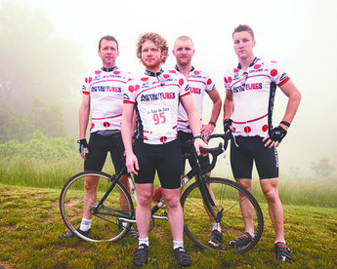
From left to right, Keith Rohr, Patrick Blair, Adam Driscoll and Alex Driscoll are members of Adventures for the Cure. The team began a cross-country race June 11, which will take them from Oceanside, Calif., to Annapolis. (Staff photo by Sarah Nix)

Patrick Blair doesn't get bent out of shape when people call him crazy. Instead, he seems to almost expect it.

"People say 'You're doing RAAM? That's crazy.' And then they find out that we're doing it on fixed gear bikes and they go, 'That's super crazy,'" he said.

Blair is one of a team of four bikers who are taking part in the Race Across America, called RAAM by those in the know, that started June 11 in Oceanside, Calif.

Blair, along with teammates Alex and Adam Driscoll and Keith Rohr, is competing for the first time in the ultra endurance race that has its finish line in Annapolis. The team is being helped in their attempt by a support crew of nine, driving three back-up vehicles.

"I think they're even more excited than I am, which is crazy," Blair said of his support staff. "It's pretty intense. I mean, I get a million e-mails about all the planning everyday. It's going to be really tough on everyone; it's 24 hours of going."

Although this is Blair's first time racing cross-country, it is the second time he has made the trip across America on a bike. Two years ago, he and teammate Adam Driscoll joined up with fellow biker Jesse Stump to do a 6,500-mile fund raising ride from Bellingham,Wash., to Ocean City.

Blair and Driscoll, who were roommates in college, founded a 501c3 non profit, Adventures for the Cure, in 2005."We decided that we should be doing more to help other people," Blair said.

Their first adventure was a 320 mile trek from Catonsville to Ocean City and back, raising $7,000 for the American Diabetes Association. They chose that charity for their first philanthropic endeavor because Driscoll has type 1 diabetes.

Madi West, a member of their 2008 RAAM support crew, met Blair and Driscoll when her husband Mike started riding with them in the mornings. The Morning Ride encompasses a 25 mile loop that draws many cycling enthusiasts from around the region, and begins and ends in Ellicott City.

"They're kind of the example of twenty-somethings getting out and making a difference in the world. ... They started working and had good jobs, but they also figured that there has to be more to life than sitting behind a desk," she said.

Rohr, an Ellicott City resident, also met Blair and Driscoll on the morning ride. After a long hiatus, he picked up cycling again in 2005.

"It was my 30th birthday and I wanted to get back into it," he said."You know, Ellicott City is full of cyclists and I ended up buying a bike on eBay and these guys from the Bike Doctor put my bike together. And they said that there's this morning ride and they meet at Childtime on the corner of (routes) 103 and 104."

Rohr was intrigued when he heard Blair and Driscoll were planning on entering the race. He was especially interested when Blair told him they were doing the race on fixed gear bikes.

"That's a big deal, as a cyclist. They're pretty strong cyclists to be able to do this. Other cyclists are always saying, 'You guys are nuts,'" he said.

Rohr added in an e-mail that the Surly Steamrollers they will be riding are fixed gear single-speed bikes.

"The bike has no free wheel; therefore, it does not coast at all. Hence one must pedal constantly to maintain movement," he wrote. That includes peddling downhill as well as up.

Trip involves lots of details

The logistics of supporting the team throughout the race are monumental. Detailed plans and schedules had to be worked out in advance so that the bikers are able to ride around the clock. The bikers do not ride at the same time, but tag-team, each racing for 30 minutes before trading off with their partner. Each pair goes for six hours at a stretch, then rests in the RV, getting as much sleep as they can. The team is aiming to keep up a constant speed of about 19 miles per hour.

"We only race one person at time. ... There's an RV, a follow vehicle and a leap-frog vehicle," West said. "There are always two people per vehicle, a driver and a navigator. The follow vehicle is always with the cyclist. The rider will have a headset on and we'll have walkie-talkies. We give them directions on where to turn."

Training tough for event

Training intensively for the race didn't phase Blair, who would do the 25-mile morning ride, bike to work and then put in another 20 miles after work.

"I guess I'm always training for these long-distance events. I've done two Ironman triathlons and a bunch of marathons," he said.

Still, he is concerned about having to keep up the killer pace that they set for themselves as a goal.

"We've trained for five months, which is probably not enough," he said. "Others have done it for almost a year. I'm a little nervous about it. I'm worried about on the sixth or seventh day, am I going to be able to keep the pace that I want to?"

Although most RAAM competitors are there purely to race, Blair and his teammates are also raising money for Adventures for the Cure. As a last hurrah before flying out to California, the team joined a 62-mile Maryland Tour de Cure ride June 7, which began at Meadowbrook Park, in Ellicott City.

"Sixty miles isn't that much, really. It'll be a nice little ride that won't phase us at all," Blair said.

For more information on the team and the Race Across America, or to view documentary movie clips of Blair and Adam Driscoll's 2006 cross-country bike trip, go to www.adventuresforthecure.com.
Velo News: New film on single-speed trans-continental ride to be show at the Tour of Missouri
http://www.velonews.com/article/81298
Posted Aug. 4, 2008

Adventures for the Cure: The Doc
To be Screened After Rolla’s Tour of Missouri Stage 4 Finish

Rolla’s Diabetes Education Fund announces that a screening of Adventures for the Cure: The Doc will be held in Castleman Hall after the Tour of Missouri Stage 4 award ceremony. Castleman Hall is located immediately behind the Stage 4 finish line and across the street from the Tour of Missouri Health and Wellness Expo. The documentary will be shown shortly after the Stage 4 awards ceremony, approximately 4:30. Admission is free and there will be door prizes.

The director, editor, and members of the cast will be on hand to discuss the documentary and their recent participation in the Race Across America – also accomplished on single-speed, fixed gear bicycles.

Adventures For the Cure: The Doc chronicles the incredible, 6,500 mile trek made by 3 young men across the United States on single-speed, fixed gear bicycles in order to raise money and awareness for diabetes, and to help disabled children in Kenya. In particular, it focuses on one of the riders, Adam, who as a Type-1 diabetic has to manage his illness while riding up to 150 miles a day through rugged terrain, and on the touching stories of two diabetic children the group meets along the way. The film is narrated by three-time Tour de France winner Greg LeMond.

Adventures For the Cure: The Doc won the People's Choice award at the Beloit International Film Festival and has also been featured as an official selection of the international Bicycle Film Festival 2008.
Advertisement

Official movie website http://www.videe-os.com

This event is made possible through the generosity of : Route 66 Bicycles, St. John's Sports Medicine, and the Missouri University of Science and Technology.
CeraSport Sponsored "Adventures For The Cure" Begins RAAM 2008
http://www.ceraproductsinc.com/news/pr_61108.html
For Release: June 11, 2008

Contact: CharleneRiikonen 410-309-1000
charlene.riikonen@ceraproducts.us

Adam Driscoll, Pat Blair, Alex Driscoll and Keith Rohr of Adventures For the Cure, began the Race Across America, which begins in Oceanside, California and ends in Annapolis, Maryland. The route is over 3000 miles, touching 14 states and climbing over 100,000 feet. Teams typically cross the country in 6 to 9 days, averaging 350 to over 500 miles per day. Solo racers finish in 9 to 12 days, averaging 250 to 350 miles per day. Teams have a relay format and race 24 hours a day. Solo racers have the challenge of balancing a few hours of sleep each night against race deadlines. During the race the team members will be using CeraSport to help avert cramping. One of the team members who is diabetic, will be using it to help avert insulin spiking that happens with typical sports drinks.

Adventures For The Cure is a 501 (c)(3) tax exempt organization that exists to raise awareness for Diabetes, to show those diagnosed with Diabetes and their families how leading a healthy and active lifestyle can move you beyond your percieved limits, and to raise funds for Diabetes research. The organization also raises awareness and funds for other causes that the board of directors has selected. In the past we have raised funds for the following organizations: The American Diabetes Association, Kupenda For The Children, The Blood:Water Mission and the Juvenile Diabetes Research Foundation.
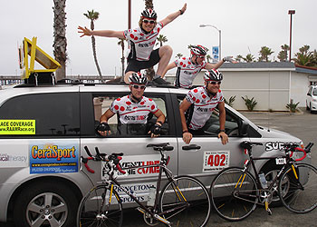
CeraSport is a rice-based oral rehydration and energy drink, which restores essential salts and fluids to prevent
and correct dehydration and enhance athletic performance. CeraSport was developed by Cera Products along with
world health experts, including physicians at Johns Hopkins, The Mayo Clinic, Harvard University and other experts
at leading food and pharmaceutical manufacturing companies. Among other athletes that use CeraSport are elite
athletes in the U.S military, including U.S. Army Rangers and Navy SEALs, cycling clubs including LSV in Baltimore,
HPC Coaching in Virginia, California State Power Lifting Champion Dr. Edward Dudley-Robey, and California Double
Century Cyclist Robert Choi.

About Cera Products Inc.
Established in Maryland in 1993, Cera Products scientifically developed its high performance medical and sports
rehydration products along with world health experts - including physicians at Johns Hopkins, the Mayo Clinic,
Harvard University, University of Maryland, Tufts University Schools of Medicine, the Food and Drug Administration,
Centers for Disease Control - and with experts at leading food and pharmaceutical manufacturing
companies. For more information go to www.ceraproductsinc.com.

Cera Products Press Contact:
410.309.1000 or sales@ceraproducts.us
Diabetes Living Today (Radio Interview)
http://diabeteslivingtoday.com/2008/04/20/this-week-dr-jon-s-heist-family-practice/
Listen here: http://diabeteslivingtoday.com/audio/dlt018.mp3
4/15/08 ~ Adventures for the Cure
Published on April 20, 2008 in Recent Broadcasts.

This week Kitty and Dr. Fallon will be joined by Adam Driscoll, Mike Caputi and Patrick Blair from “Adventures For The Cure” Adventures for the Cure is a 501 (c)(3) tax exempt organization that exists to raise awareness for Diabetes, to show those diagnosed with Diabetes and their families how leading a healthy and active lifestyle can move you beyond your percieved limits, and to raise funds for Diabetes research. The organization also raises awareness and funds for other causes that the board of directors has selected.
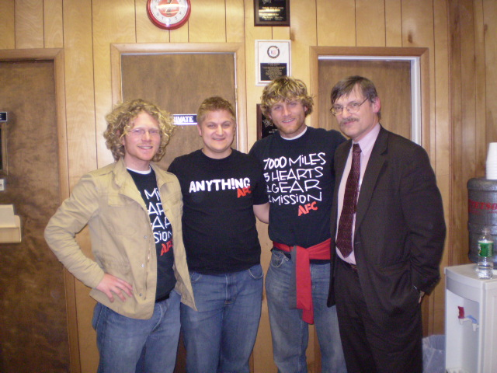
Photo Above: Patrick, Mike & Adam with Dr. Fallon
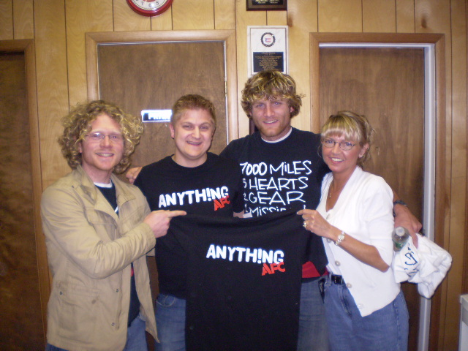
Photo Above: Patrick, Mike & Adam with Kitty
Ocean City News
http://www.delmarvanow.com/oceanpines/stories/20060830/2323826.html

OCEAN CITY – Adam Driscoll, a Type 1 diabetic, and his team of friends have pedaled more than 6,000 miles on a fixed-gear bicycle since June 1 and they’ll bring their ride to a close in Ocean City on Saturday.
“It’s to the point where we’ve gone 6,000 miles and we want the shortest route to the end,” Driscoll said last week. “We want to be home and see our friends and family, it’s been such a long journey.”
Driscoll was joined on the trip by his team of four others, fellow riders Jesse Stump and Patrick Blair and two support car drivers, Andy and Phillip Knowlton, who are also making a documentary of the trip.
“Last summer Patrick decided to bike to Ocean City and back to the Towson area, we did it in two days,” Driscoll said. “We raised $7,000. Then I decided each summer we’d try and help out diabetics and if another cause comes to bat we’ll help them out too.”
He and his friends came up with the idea to bike across the country.
“We all work good jobs but we wanted to make a difference,” he said. “We’re computer people and we didn’t feel like we were fulfilling our lives.”
The ride began in Bellingham, Wash., where Driscoll, Stump and Blair traveled for the Ski to Sea relay.
“This year we didn’t fly back,” he said. “We’ve been through all different kinds of cities, some where the population was 22. Kansas was super small, most of the towns were 50 to 100 people. We’ve been through some big cities, too.”
He said their path went up and down, not straight across the country, and the terrain was similar.
“We just got out of the Appalachian Mountains,” Driscoll said last week. “It was harder than the Rockies because of the steepness of the hills and we only have one gear which makes things more difficult.”
Driscoll said they chose to do their trip in a fixed gear to make them different and show they were up for the challenge.
“You can’t coast so even on the downhill we’re pedaling,” he said.
It would seem to be an extra hardship, but Driscoll and his teammates are in excellent condition. He said they met while running together in college at University of Maryland Baltimore County.
“It all depends on the day, today was really easy for us because it was just flat and we’ve had the wind at our back at times,” he said. “When we were in Kansas we wouldn’t have made it without the support van because there are not that many places to stop for miles and miles.”
The group returned to Maryland last week with about $10,000 raised for the American Diabetes Association and about $15,000 for the Kupenda for the Children fund which will build a facility for children with diabetes in Africa.
“Our goal for Kupenda is $20,000. Our ADA goal is more about awareness,” Driscoll said. “I’ve met a lot of people along the way. Sometimes the parents are very upset about their son or daughter being diagnosed with diabetes.”
Driscoll said through meeting people with diabetes in the towns and cities they passed through he was able to spread the word about the disease and raise money for the foundation.
They did a couple of events before leaving to raise a chunk of the money and the rest was received through pledges and donations.
When they arrive in Ocean City on Saturday they’ll be hosted by a party at Shenanigan’s on the Boardwalk, the same place where Driscoll and Blair finished their much smaller ride last summer.
They plan to host a finishing ride on Sunday beginning at Stephen Decatur High School. To register, visit www.adventuresforthecure.com.

Charity ride to end in resort
By Laura D’Alessandro
Staff Writer

Southern MD News
http://www.thesouthern.com/articles/2006/08/08/local/17170320.txt
Cyclists going cross-country for a cure
by andrea hahn, the southern

MURPHYSBORO - Three guys who wanted to do some good decided to bicycle from coast to coast to raise awareness for some really wonderful causes.

Feeling that merely bicycling thousands of miles was overdone, they decided to add a twist - they would use fixed-gear bicycles. Fixed gear means more than just no shifting. It also means, never stop pedaling. When the back wheel turns, so do the pedals. There is no possibility of coasting - not even down hills.
Adventures for the Cure - the three guys and their two support drivers - were in Murphysboro on Monday retreating from the jungle-like atmosphere of high humidity. They are Adam Driscoll, Patrick Blair and Jesse Stump. They were overnight guests of Mark and Sue Gindlesparger of Murphysboro - accommodations arranged for them by the Gindlespargers' son, who is a bicycle enthusiast currently living in Arizona.

"We had really good jobs, but we didn't feel like we were making a difference," Driscoll said.

As an experiment, they made a two-day fundraising round trip that saw them riding more than 300 miles. It was fun, they raised some money - about $7,000 - so they decided to do it again. But bigger, better, longer. The idea of the coast-to-coast trip was born.

The AFC group rides for two causes. They ride for the American Diabetic Association because Driscoll has Type 1 diabetes. They ride for Kupenda, a charity that helps special needs children in Kenya, because they can better see the impact of their donated dollars in a smaller charity.

Accordingly, the AFC ride isn't just about raising money. It is also about raising awareness. Driscoll was diagnosed with Type 1 diabetes when he was 11. He hasn't let that stop him from running cross country and track in college or prepping for the Duathlon world championships. He uses the cross-country bike ride as a way to demonstrate that diabetes doesn't have to stop a person from living not just a normal life, but a very active and physically demanding one.

He is also promoting an insulin pump produced by Medtronic Minimed. The pump erases the need for needle injections. Without it, Driscoll said he doesn't think a multi-month bicycle trip would have been a possibility for him. He said, though, that many diabetic people he has met either don't know about insulin pumps or are afraid to try them.

"A lot of people don't want to make the change," he said. "But it's amazing - you have such a more free life. I don't know how I would do without it."

Driscoll said the pump has freed him from the rigid schedule of insulin shots. He still has problems if he misses a meal or waits too long before eating. But that hasn't caused any major problems or any delays on the bike ride.

Stump, too, is showing that medical problems don't always have to be sidelining. Just three weeks before the ride started in Bellingham, Wash., his thyroid was removed and a few weeks before that, a lump that proved to be cancerous. The recovery period kept him out of training for awhile, but it didn't keep him from starting the ride with Blair and Driscoll.

"The first week was a shock to my system," he said. "That was the closest we came to an injury - it just really pounded my legs."

And to think he passed on a two-month trip to Europe to ride and raise awareness and dollars.

The group found out about Kupenda after meeting its founder, Cindy Bauer, at a church retreat. Later, Driscoll and Blair went to Kenya to see for themselves. They came away more inspired than ever to make a difference.

So far, the group has raised about $13,000 for Kupenda and $9,500 for ADA.

As for the day-to-day practicalities of riding fixed gear bicycles for 6,000 miles, the guys have learned that it would have been nice to have sleeping bags in the Rockies, that picnic tables make good beds when you are really tired, and that roads in Colorado don't have wide shoulders.

They are stoic about the difficulties they have encountered. "Having really low expectations helps," Stump said. "We have really strong faith," Blair said.

The group is set to head out from Murphysboro at about 8:30 a.m. today. Sean Boyle of the Shawnee Mountain Bike Association said he hopes to get a group together to ride to the next stop in Elizabethtown.

"I think I can ride that far," he said. "I ride 40 miles a day most days, but for these guys that's nothing."

For more information or to donate, log onto www. adventureforthecure.com.

andrea.hahn@thesouthern.com
(618) 529-5454 ext. 5076
Southern MD News (2)
http://www.somdnews.com/stories/072806/recmor165601_32134.shtml

Biking across this country for another country

La Plata graduate helps fight diabetes, disabilities in Africa’s children

Friday, July 28, 2006
By Dallas Cogle
Staff Writer

This is no ordinary biking trip.
Not just because Jesse Stump, a 2001 La Plata graduate and county native, and a pair of close college friends are in the midst of an extreme bike ride across the United States, covering between 7,000 and 7,500 miles in a little more than three months.
They embarked on their journey May 30 in Bellingham, Wash., near Vancouver, British Columbia, and are slated to finish in Ocean City on Sept. 3.
Also, not just because the three 2006 University of Maryland-Baltimore County graduates who were members of the cross country and track teams at the NCAA Division I school have elected to make the grueling trip on fixed-gear, single-speed road bikes.
The fixed-gear bikes make an immense challenge that much more difficult.
‘‘We just have one gear, so there’s no free wheel,” Stump said on a resting day two weeks ago via a phone conversation while in a Hutchinson, Kan., Wal-Mart. ‘‘So I have to peddle the entire time. It was a little difficult through the Rockies because you can’t let it coast. It’s as hard going downhill as it is going up. It’s pretty uncomfortable, because you’re going so fast. And we hear the Appalachians are a lot steeper, so it’s going to be difficult.”
But not even the riding and weather elements are what make this trip along the Transamerica Trail — specifically mapped out for bikers to travel from one coast to the other — and deviating off the main route onto other courses in Iowa and around Chicago so inspiring, purposeful and unordinary.
‘‘The winds out here on the plains are pretty bad,” Stump said last week. ‘‘We just missed a tornado in Pueblo, Colo. We had just left, and a day or two later is when the tornado went through there.”
It’s the mission behind the mission that has Stump and cycling partners Adam Driscoll and Patrick Blair so driven to conquer 14 states across the country while traveling on average of 100 miles per day — equating to around eight hours — and about 17 to 20 mph.
The trio has become missionaries on their bikes, spreading the word of awareness for the American Diabetes Association while raising money toward Kupenda for the Children, an organization that provides support for children with disabilities in Africa.
Both causes hit home for the bikers, who are joined by a support vehicle on the trip that is driven by brothers Phillip and Andy Knowlton, who are turning the challenge into a documentary.
Driscoll has Type 1 Diabetes and enjoys undergoing physical tests of stamina on his body, such as his current situation, to prove that the condition will not keep him from an active and healthy lifestyle.
The other four members of the team are just as passionate against diabetes.
Kupenda was brought to light for Stump and Co. when the organization’s founder, Cindy Bauer, spoke at their church in Baltimore. She talked of how Kupenda has made a major impact on the lives of children living in poverty-stricken Kenya, and the UMBC products were moved to use their athletic talents as a means of raising funds for the important cause.
The mission
Stump, Driscoll, Blair and the Knowlton brothers comprise the organization called Adventures for the Cure (AFC).
Their Web site, www.adventuresforthecure.com, is constantly updated with details of the cross-country endeavor and stocked with information, pictures and insight into what their mission is all about.
Their goal is to raise $20,000 for Kupenda to build a second boarding house in Kenya. Driscoll and Blair have already visited the African country and testify on the Web site about the important work being accomplished by Kupenda.
As of Sunday’s posting on the site, AFC had raised more than half of its goal for Kupenda at $11,834.62.
Almost $9,000 had been raised toward the American Diabetes Association.
Anyone can make a contribution by logging onto the site.
Throughout their ride, Stump, Driscoll and Blair look to give speeches wherever they are invited about the inspiration behind the journey.
In Pueblo, Colo., shortly after July 4, they spoke to a group of 50 high school students.
‘‘Adam talked about living with diabetes and how important it is to live with exercise and to take care of yourself,” Stump said. ‘‘It’s important for him to show that he can still do whatever he wants.”
Last Tuesday in Peru, Neb., the bikers visited a church’s vacation Bible school where they talked to kids about their trip and doing good for others. Diabetes and Africa were at the center of the discussion, and the kids had tons of questions.
The AFC’s Christian faith is an aspect that is woven into the objective of the trip.
Each page of the Web site is headed by the Biblical scripture reference, Matthew 6:25-34, which illustrates the concept of not worrying about the obstacles and challenges of life because of the hope that is found in God.
‘‘We’ve got a lot of faith and have put [the trip] in God’s hands, else we would be a nervous wreck,” Stump’s mother, Andrea, said about the anxieties that she and her husband have experienced concerning their son’s safety and well-being, awaiting his phone call or the group’s Web site posting before nodding off to sleep each night. ‘‘All three of these guys [on the bikes] have great jobs and live in a little apartment in Baltimore. They are involved with their church in Baltimore. All three are single so this was the right time in their life to do this.
‘‘It’s kind of neat because the other two [bikers] were raised exactly the same way as Jesse. Their parents remind me of myself and my husband.”
Life on the bike
In the course of a typical eight-hour day on the bike, the group takes short breaks. But they stay driven to reach their destination for the day.
Sometimes their destination is in a house or church, as they have made many new friends along the way who have contacted them via their Web site and offered them sleeping quarters.
Such was the case last Friday and Saturday, as a pastor of a church in Sergeant Bluff, Iowa, offered up three beds, his back yard for pitching a tent or the basement of his house for Stump and Co. to stay.
The pastor and his wife left their address and cell phone number for the group to contact them.
On other occasions throughout the trip, lodging has not come so comfortably or easily.
On July 9 in Ness, Kan., the group was pitching their tent in a park when a storm was seen on the horizon heading their way. So they went to a hospital across the street and asked if they could set up shop in its lobby for the night. They were told they could unless the lobby was needed for hospital care.
Right before falling asleep, a nurse informed the group that they had to leave because the waiting room was needed for an emergency, as an ambulance’s lights were flickering outside.
So Stump and his comrades moved back outside for the night, inside sleeping bags atop picnic tables under a park pavilion. They remained dry under the pavilion while it stormed throughout the night.
Now, more than halfway through the trip, the group has just about experienced it all with making do without the amenities they are used to in their normal everyday lives.
‘‘The first two weeks of the trip, we had a lot of places to stay — to shower and eat dinner,” Stump said. ‘‘The next two weeks we had to shower in streams and so forth, because it was really hard to get in touch with people. We’d go through towns with only 50, 60 people. It’s been a different experience.”
At each town, the group fills up a five-gallon jug of water that is kept in the trunk of the support vehicle to keep the bikers hydrated.
‘‘The wind really dehydrates you,” Stump said. ‘‘[At the beginning of the trip] we were covered in a ton of salt because of not getting enough water.”
On July 17, the bikers completed their most rigorous day of the trip: 150 miles in 100-degree weather before stopping in Peru, Neb.
‘‘That was brutal,” Stump said last Wednesday while in Council Bluffs, Iowa.
They were rewarded with a stay at a bed-and-breakfast last Monday and Tuesday nights and prepared for a well-known biking trail through Iowa that began Sunday and lasts through Saturday.
They have the opportunity to spread the message behind their trip at expos each day after finishing a different leg of the Iowa course. They were scheduled to bike to Newton, Iowa, Wednesday.
Dealing with cancerbefore the trip
Stump’s athletic career is highlighted by 12 years as a distance runner.
The 23-year-old was a standout in track and cross country for La Plata High and earned athletic and academic scholarships to attend UMBC.
While Driscoll and Blair have been involved in biking for some time, Stump just started in the sport about six months ago.
‘‘It’s very similar,” Stump said, comparing biking to running. ‘‘Spending a lot of years running has really helped in the whole mental aspect of getting out there every day and knowing you’re not going to get a day off.”
On July 16, the three were aired in a television sports report on an ABC affiliate in Kansas where Stump, Driscoll and Blair were each interviewed and their intentions for making the trip across the country were discussed.
But Stump’s presence on the trip was in jeopardy just weeks before it was set to begin.
He was diagnosed with thyroid cancer. His thyroid was removed May 8 — three weeks prior to launching his journey from the west to East Coast. The cancer was detected when he discovered a lump in his throat.
‘‘Actually, I had quite a few hesitations about going on the trip,” Stump admitted. ‘‘I wanted to make sure all the cancer was gone. The first few weeks of the trip, I was a bit tired.”
He has to take thyroid pills every day for the rest of his life.
Both he and Driscoll must take medication in the middle of each night, thus breaking their sleep.
‘‘He thought after the first month [of the trip] that he might not be able to finish,” Andrea Stump said about her son. ‘‘But he talked to someone on the Internet who is a distance biker and is also without a thyroid, and that person said you have to take the medication about three hours before starting to bike the next day.”
The advice has been golden to Stump, as he has not struggled with the fatigue that bothered him early on in the trip.
A couple times throughout the trip, he has needed blood work done in labs, which then sent Stump’s sample to his doctor in Baltimore.
‘‘He’s doing great right now,” Stump’s mother said last Tuesday.
‘‘I’m feeling good,” Stump added. ‘‘Hopefully, it’ll be all downhill from here. But you never know.”
Lately, the bikers have been waking up earlier than usual to get on the road and beat the heat. They are now biking by 5:30 each morning when setting out for a new destination.
E-mail Dallas Cogle at dcogle@somdnews.com.
Baker City, Oregon News
http://www.bakercityherald.com/news/story.cfm?story_no=3559
Riding coast to coast without coasting
Published: June 15, 2006
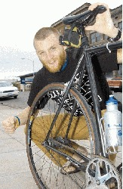
Adam Driscoll, who has type 1 diabetes, is pedaling his single-speed, fixed-gear bicycle 6,000 miles from Bellingham, Wash., to Ocean City, Md. Driscoll, 24, who lives in Maryland, is raising money for diabetes research and to build a school for poor kids in Kenya. He is riding with two friends. Their fixed-gear bikes aren't capable of coasting — they have to pedal all the time, even when descending. The trio spent Monday and Tuesday nights in Baker City, and rode on to Halfway on Wednesday.
Baker City Herald/S. John Collins

By JAYSON JACOBY
jjacoby@bakercityherald.com
Adam Driscoll is pedaling his bicycle across the United States, and gravity is not his friend.
Not even when he's rolling down hills.
And he's already rolled down some pretty steep ones — the sort of slope where they post big eye-scalding yellow warning signs at the top, urging truck drivers to test their brakes before plummeting down the grade.
The sort of slope that spreads smiles across most cross-country bicyclists' faces because they know, as they crest the summit, that for the coming downhill miles gravity will whisk them along at a brisk pace even as they rest their weary legs and wheezy lungs.
Driscoll is not like most bicyclists.
But he's used to fighting forces he can't control, so he figured why not spar with one of Newton's laws all the way across America, as well.
Driscoll, a 24-year-old from Maryland who spent Monday and Tuesday nights in Baker City and then rode on to Halfway on Wednesday, has type 1 diabetes.
That's the least common, but often the most severe, form of the disease.
Driscoll's pancreas doesn't produce insulin, a hormone that helps the body transform blood sugar into energy.
He wears a device that pumps insulin into his bloodstream every day to control his blood sugar level. Excessive blood sugar can cause all sorts of problems, among them blindness and heart disease.
But Driscoll, who was diagnosed with diabetes at age 11, doesn't dwell on the bad things that can happen to people who suffer from the disease.
He focuses instead on the good things they can accomplish as they defy diabetes' potentially debilitating effects.
Things like bicycling across America to raise $20,000 to build a school for 40 poor kids in Kenya, for instance.
Constructing that school, and inspiring diabetes patients, are the overriding goals for Driscoll and for his two friends who plan to pedal every mile with him: Patrick Blair, 25, and Jesse Stump, 23.
Neither Blair nor Stump has diabetes.
Stump has had to endure his own medical travails recently, though.
On May 8, less than a month before the bicyclists started riding, surgeons removed Stump's thyroid gland, fearing it might be cancerous.
Stump is still adjusting to his post-operation medication, but he has pedaled every mile beside his buddies.
"It is amazing how quickly he has recovered from such a tremendous shock to his system!!" Blair wrote on the Internet blog he updates daily. "Jesse Stump is tough as nails!!"
Actually all three friends look pretty stout.
Driscoll and Stump ran track and cross-country in college, and Blair competes in triathlons. Each has the lean build and sinewy muscles of the dedicated athlete.
Although the trio, who met while they were students at the University of Maryland-Baltimore County, intend to ride from the Pacific Coast to the Atlantic Coast, they won't do any real coasting in between the two oceans.
Actually they can't coast even if they want to.
That's because all three are riding fixed-gear bicycles.
Which means, to put it in the simplest terms, that Driscoll, Blair and Stump have to pedal all the time. Unlike most bicycles, their rear wheels don't spin independently of the pedals. When they descend a hill they can't put their feet on the pedals and let their lungs and their muscles rest while gravity pulls them along.
"No coasting," Stump said.
No shifting to a low gear to make for easy pedaling, either.
The bikes have only one gear, not 21 or 24.
And that one gear is a high one, Driscoll said — equivalent, on a conventional bike, to riding with your chain on the biggest front ring, he said.
He said he picked fixed-gear bikes for the trip in part because he wants to prove to fellow diabetes sufferers that not only can they complete such a journey despite the disease, but that they can do so under the most arduous conditions.
Plus, he thought fixed-gear bikes would attract more attention.
"We wanted to be unique in some way," Driscoll said. "Everyone knows a biker who has biked across the country. But no one knows a biker who has biked across the country on a fixed-gear bike."
"We haven't met one yet," Blair said.
Neither have the three friends encountered a cyclist who is tracing their considerably-less-than-direct route across America.
They started riding on May 30 in Bellingham, Wash., and rather than bearing due east — the shortest, easiest way — they first went south for about 500 miles. They veered east at Eugene, and when the trio rolled into Baker City Monday afternoon — pedaling, of course, not coasting — they had covered 996 miles.
Monday's 65-mile from near Prairie City was almost their shortest one-day ride — they've pedaled as far as 130 miles, and this weekend's slate includes a 150-mile day in Idaho.
"But we're still on schedule, which is great," Stump said.
That schedule has them finishing their estimated 6,000-mile trek on Sept. 3 at Ocean City, Md.
The cross-country ride isn't the friends' first foray into fund-raising.
Last summer Driscoll and Blair rode 320 miles in Maryland and raised $7,000 for the American Diabetes Association.
"We wanted to do something bigger," Driscoll said.
Pedaling from coast-to-coast on fixed-gear bikes, for instance.
"But we also were looking for another good cause besides diabetes," Driscoll said.
Then, during a church retreat, he and Blair watched a video that showed the plight of Kenyan kids who had no school.
"That inspired us," Driscoll said.
That inspiration prompted him and Blair to travel to Kenya in January. There they visited the village where the school will be built if they reach their $20,000 goal.
"It was a life-changing experience," Driscoll said of the trip to Kenya.
He collected about $8,000 in donations for an African childrens' aid group, Kupenda for the Children, before the trio departed Bellingham. Driscoll estimates they've brought in another $1,000 since.
Although both Driscoll and Blair have full-time jobs (Stump is graduating this year), Driscoll said the group wants to take extended vacations every year to embark on some sort of fund-raising campaign.
Perhaps next year they'll run rather than ride — all three competed in cross-country and track during college.
Regardless, all three said they hope they can continue to travel as a trio.
(As a quintet, actually — two brothers drive the 1992 Nissan Sentra that serves as the bicyclists' support car.)
Blair said they've met several individual cyclists who also are trying to pedal from one coast to the other.
"I feel sorry for those guys, riding all alone. This is better," Blair said, glancing at Driscoll and Stump.
"We're just hanging out."
And pedaling.
Always pedaling.
More information about the trip is available online at http://adventuresforthecure.com/index.htm.
Congressional Record
http://frwebgate.access.gpo.gov/cgi-bin/getpage.cgi?dbname=2006_record&page=E1036&position=all
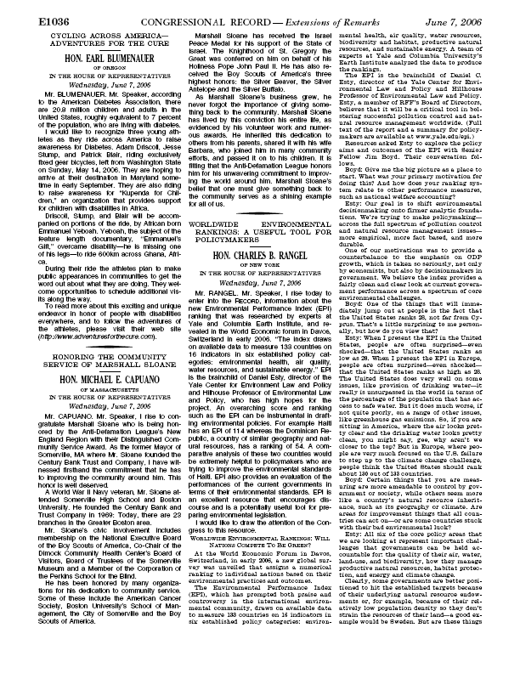
Baltimore Examiner
UMBC grads complete 6,200-mile charity bike trek

(Kristine Buls/Examiner)
Cyclist Adam Driscoll gives 5-year-old Braden Hamelin a red diabetes-awareness bracelet during a stop at Sinai Hospital.
Ron Cassie, The Examiner
Sep 1, 2006 5:00 AM (1 hr 49 mins ago)
BALTIMORE - It wasn’t the all-day climbs in the Rockies, or the twisting turns down the Appalachian Mountains they feared the most — it was Kansas.
Flat Kansas, supposedly a haven for cyclists, was a disaster.
“It was hot — and so windy it was hard to stay on the bike at times — and stormed like mad,” said Patrick Blair, 24, who rode 6,200 miles this summer with former University of Maryland, Baltimore County pals Adam Driscoll and Jesse Stump. The trio was raising money for the American Diabetes Foundation and Kupenda, a Baltimore County nonprofit managing eight schools for special needs children in Kenya.

They outlasted the prairies, riding across country, doing mini-events, TV, radio and newspaper interviews to highlight their causes, and now are close to their target of raising $20,000 for Kupenda and $10,000 for diabetes awareness and research. Type 2 diabetes “is practically sweeping the United States,” said Driscoll, who’s been taking insulin since he was 10. “But I also want to show people with Type 1, what I have, that it doesn’t have to slow you down — anything is possible.

“I rode a tandem bike 40 miles with an 11-year-old girl, Tess, with Type 1 diabetes, as part of Cycle Across Iowa,” Driscoll recounted. “You could see the difference it made in her parents, who had been kind of sheltering her. She was so happy, though. When she got off the bike, she had tears in her eyes.”

“If we raise $20,000 for Kupenda, it will change a lot of kids’ lives,” Blair said. “People there don’t have cars. If you’re a handicapped kid and live three miles from school, you’re just not going.”

Thursday afternoon, they finally arrived home. However, they first stopped to visit children at Sinai Hospital, where they’ve tracked the cyclists’ progress across the country.

Driscoll compared insulin pumps with 5-year-old Braden Hamelin.

“Braden was really excited to meet Adam,” said his mother, Tracey Hamelin.

Braden, in kindergarten at Timonium Elementary, doesn’t ride a bike yet, but said he plans to learn soon. Asked if he thinks one day, he might be able to ride across the United States, Braden said, “I don’t know; that sounds like a lot of work to me.”
I
mpossible, right?

“Not impossible,” Braden said.
Examiner
Baltimore Examiner 2
https://www.examiner.com/a-78791~Biking_for_a_cause.html
Biking for a cause

(Kristine Buls/Examiner)
UMBC grad students Patrick Blair, left, Jesse Stump, center, and Adam Driscoll plan to bike 6,000 miles across country to raise money for American Diabetes Association and a Kenyan boarding school.

Ron Cassie, The Examiner
Apr 15, 2006 5:00 AM (154 days ago)
Current rank: Not ranked
Baltimore County - Cindy Bauer still sounds a bit overwhelmed when she recalls her first meeting with University of Maryland, Baltimore County, graduates Patrick Blair and Adam Driscoll.
Bauer is the founder of Kupenda, a Baltimore County-based nonprofit that manages eight schools for special needs children in Kenya.
“All of a sudden, they ran up to me after my presentation at a retreat,” Bauer said. “And they were like, ‘We’re going to raise money for you.’ Then they said, ‘We’re going to Africa with you too. We want to see where the money we raise is going to go.’ ”
Now, with Jesse Stump and Phil Knolton, two of their former UMBC cross-country and track teammates, they’re taking three months off to ride single-track, fixed-gear bikes 6,000 miles across the U.S. to raise donations for Kupenda, which means “to love” in Swahili.
“People there don’t have cars,” Blair said of the coast of Kenya where the schools are located. “If you’re a handicapped kid and live three miles from school, you’re just not going.”
Last summer, the two 24-year-olds rode from Baltimore to Ocean City and back, raising $7,000 for the American Diabetes Association.
Type 2 diabetes “is practically sweeping the United States,” said Driscoll, who’s been taking insulin since he was 10. “But I also want to show people with Type I, what I have, that it doesn’t have to slow you down — anything is possible.”
“If we raise $20,000 for Kupenda, it will change a lot of kids’ lives,” Blair said.
Mid Atlantic Monthly
http://www.imakenews.com/usatma/index000113647.cfm?x=b11,0,w

REGIONAL ATHLETES TO BIKE ACROSS U.S. TO RAISE FUNDS AND AWARENESS

Two Mid-Maryland Tri Club members, Patrick Blair and Adam Driscoll, will be biking across the country in June, July, and August 2006 on fixed gear, single speed, road bikes to raise funds and awareness for the American Diabetes Association and Kupenda for the Children, an organization whose mission Blair describes as “helping special needs children in Africa.” It will be close to 6,000 miles when they conclude their ride in Ocean City, Maryland on September 3rd. Blair and Driscoll will be riding on behalf of Adventures for the Cure. For information on how you can support these athletes and their fundraising efforts, please visit (www.adventuresforthecure.com).

Grace Fellowship Church
http://home.gfc.org/index.php?zone=home&ID=1512

Spotlight: Adventures for the Cure
Contact Person:
Ministry:

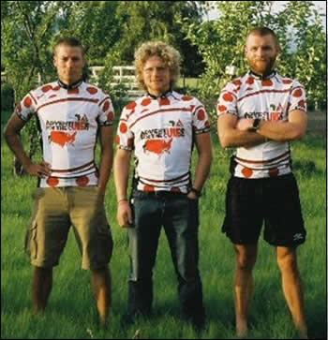
On June 1st, three SonFields Sunday school teachers left Bellingham, WA on their 6,000 mile trek across the country. Pat Blair, Adam Driscoll (5th grade SonFields teachers), and Jesse Stump (3rd grade SonFields teacher) are biking across the country to raise awareness and financial support for cure of Diabetes and for Kupenda for the Children, an organization that provides financial and spiritual support for children with disabilities in Africa.
Through Grace Fellowship Church, these three men came to know the Lord more deeply and met Cindy Bauer who founded Kupenda. Pat and Adam had the opportunity to visit Africa and see, first hand, the work Kupenda is doing for the children. This inspired them to raise money and awareness for not only Diabetes, which Adam suffers from Type 1, but also Kupenda.
Jesse has been involved in SonFields for over four years and Pat and Adam for over two. The three men attribute their aspirations for this trip to their experience in teaching Sunday School, going to GFC’s worship service, and their dedicated Godly friendships through their neighborhood small group. Pat Blair puts it this way, “Living life for God is like nothing else! Just look at all the things that are happening because of it!
It’s crazy when God gets in the mix!” The verse of scripture that has given them inspiration to push through the hard parts of this trip is from Matthew 6:25-34 and can be summed up by Matthew 6:33, “But seek first his kingdom and his righteousness, and all these things will be given to you as well.”
For more information or if you would like to support their causes please visit their website (www.adventuresforthecure.com). Pat , Adam , and Jesse would love if you would pray along with them as they continue their adventure for the cure!
Photo: From left to right, Jesse Stump, Pat Blair, Adam Driscoll.
Dan Tooker In The Morning (Radio)

Last Weeks Guests: Adam Driscoll
Adam and a group of individuals are biking across the country on fixed gear bicycles to raise awareness for The American Diabetes Association and Kupenda. Kupenda is an organization that helps disabled kids in Kenya. As to date, Adam has raised 10 thousand dollars for Kupenda and about 8 thousand for ADA. There’s even a documentary crew following him! Currently, Adam is camping out in Hutchinson.
Check out his trip at http://adventuresforthecure.com
ADA News

CYCLING ACROSS AMERICA (from NCD News) - Two young triathletes (Patrick Blair [not your editor] and Adam Driscoll) and a fellow athlete (Jesse Stump) will ride across America during the summer of 2006 to raise awareness and to support children with disabilities in Ghana as well as America with diabetes (see http://www.adventuresforthecure.com/webpages/mission.html). These triathletes chose diabetes since one of them (Adam Driscoll), one of the founding AFC members, has Type One Diabetes. The cyclists want to show people that having diabetes does not mean one’s life is over. They also want people know that Type II diabetes is one of the leading killers in United States and that a healthy lifestyle is very important. In addition to the three cyclists, Phillip Knowlton will be driving the support vehicle, and two of the world’s premiere endurance athletes will be joining the trio: Dean Karnazes and Emmanuel Yeoboah. Dean Karnazes is an American who has run hundreds of miles at once for to raise awareness and support for children with special health care needs. Dean is one of the world’s premiere runners and endurance athletes. Emmanuel Yeoboah was born in Africa. He biked 600km across Ghana, Africa to show others that being disabled does not mean inability. The riders will all be riding on fixed gear, single speed, road bikes. They chose fixed gear bikes to make their cross country trip that much tougher. Many people have ridden across country on bicycles but far fewer have done so with a single speed fixed gear. During their ride they hope to give speeches/talks at cities and to get the word out as much as possible about what they are doing. They want people to know about diabetes and that it can be defeated. They also want people know what it is like to be born with a physical or mental disability in an impoverished country that has traditionally viewed such disabilities as a curse. To read more about this exciting and unique endeavor in honor of people with disabilities everywhere, and to follow the adventures of the athletes, go to http://www.adventuresforthecure.com.

Route 66 Bicycles
http://www.route66bicycles.com/
http://www.route66bicycles.com/afc_stops_in_rolla.html
08/07/06:
Holy Crap, a Monday morning update? Will wonders never cease. I gotta get some info up here since the Adventures For the Cure team plugged my site on their blog. If you wanna check it out, just go to their homepage and click on the 'news' link. We had a pretty good time over here on Friday night...cranked some tunes, met some cool people, drank some high life....life's a garden, dig it. took a few pictures and you can view those right about here. Heck, make a donation to those guys if you are feeling it. They were three of the coolest dudes I'd wanna meet...and they were riding 48x16 gears with 165mm cranks across the country!! Anyway, they spent the night over at Morgan's place and took off Saturday morning for a 95-mile ride down HWY 8 to Farmington. And that was an easy day for them. Ahem...anyone else feel like a big wuss right about now?

City Biz List
http://www.citybizlist.com/lstg/lstgDetail.aspx?id=9601
Adventures for the Cure Team Celebrates Success of 6,000-Mile Cross Country Bike Ride in Hometown
Events
Reply to: info@citybizlist.com
Date: 9/1/2006 8:37:16 AM
Description:
Team Captain and Type I Diabetic, Adam Driscoll, Leads Final Leg of 30-mile Ride to Continue Raising Awareness of Diabetes Among Americans

BALTIMORE, Aug. 31 /PRNewswire/ -- A team of three Marylander's, who have ridden across the United States for the last three months to advocate diabetes awareness and raise money for the American Diabetes Association, are celebrating their success in Ocean City, Md. on September 3rd. The team, dubbed Adventures for the Cure, will ride fixed gear bicycles for the final 30 miles of their 6,000-mile cross county trek. The final leg will begin in Berlin, Md. and it will end in Ocean City. Following the ride, a public celebration of triumph will take place at Shenanigan's Bar and Grill.

Adventures for the Cure (http://www.adventuresforthecure.com/), lead by team captain Adam Driscoll, began its journey in Seattle, Washington. Driscoll, a type I diabetic, formed Adventures for the Cure to demonstrate the importance of living an active and healthy life as a diabetic. Diabetes is reaching epidemic proportions, affecting 20.8 million Americans. In fact, every 21 seconds, someone is diagnosed with the deadly disease. Maryland has a high incidence of diabetes per capita, ranking fourth in the nation alongside Alabama.

WHEN: Sunday, September 3, 2006 - 9:00 a.m.-1:00 p.m.
9:00 a.m. - 30-mile bike ride begins at Stephen Decatur High School
1:00 p.m. - Festivities begin at Shenanigan's Bar and Grill

WHERE: Stephen Decatur High School, 9913 Seahawk Rd, Berlin, Md.
Shenanigan's Bar and Grill, 4th Street and Boardwalk, Ocean City, Md.

Source: American Diabetes Association
CONTACT: Shawn McIntosh of American Diabetes Association,
+1-410-265-0075, ext. 4676, or smcintosh@diabetes.org; or Adam Driscoll of
Adventures for the Cure, +1-301-758-8218, or adrisc1@gmail.com
Web site: http://www.diabetes.org/
http://www.adventuresforthecure.com/
Contact:
Information Editor
info@citybizlist.com

Hon. Earl Blumenauer
Of Oregon
In The House Of Representatives

CYCLING ACROSS AMERICA--ADVENTURES FOR THE CURE -- HON. EARL BLUMENAUER (Extensions of Remarks - June 07, 2006)
[Page: E1036]
---
HON. EARL BLUMENAUER
OF OREGON
IN THE HOUSE OF REPRESENTATIVES
Wednesday, June 7, 2006
- Mr. BLUMENAUER. Mr. Speaker, according to the American Diabetes Association, there are 20.8 million children and adults in the United States, roughly equivalent to 7 percent of the population, who are living with diabetes.
- I would like to recognize three young athletes as they ride across America to raise awareness for Diabetes. Adam Driscoll, Jesse Stump, and Patrick Blair, riding exclusively fixed gear bicycles, left from Washington State on Sunday, May 14, 2006. They are hoping to arrive at their destination in Maryland sometime in early September. They are also riding to raise awareness for ``Kupenda for Children,'' an organization that provides support for children with disabilities in Africa.
- Driscoll, Stump, and Blair will be accompanied on portions of the ride, by African born Emmanuel Yeboah. Yeboah, the subject of the feature length documentary, ``Emmanuel's Gift,'' overcame disability--he is missing one of his legs--to ride 600km across Ghana, Africa.
- During their ride the athletes plan to make public appearances in communities to get the word out about what they are doing. They welcome opportunities to schedule additional visits along the way.
- To read more about this exciting and unique endeavor in honor of people with disabilities everywhere, and to follow the adventures of the athletes, please visit their web site Ð(http://www.adventuresforthecure.com).

Darby Newspaper
On the road to a cure
Diabetes sufferer bikes across nation to raise awareness of disease
by ANTHONY QUIRINI - Ravalli Republic
DARBY - Adam Driscoll has always been active, but one thing separated him from the others - he had type one diabetes.

Most of his life people told Driscoll that he couldn't be active or involved in sports. He is in the process of disproving this invention by riding 6,500 miles on a bicycle.

Driscoll, along with his best friends Jesse Stump and Patrick Blair, are riding across the country to raise awareness for diabetes in Adventures for the Cure. They started in Bellingham, Wash., on May 30 and will arrive in Ocean City, Md., on September 3. On Tuesday, the group pedaled through the Bitterroot Valley, stopping in Darby for lunch.

The men have know each other for years - in college ran track together and participated in other activities. Their cause for the ride is simple: raise awareness of diabetes and make a difference.

“We want to make a difference and do something to inspire people - using our love of biking and athletics to help others and inspire and raise awareness for diabetes is what makes us happy and inspires us,” Blair said. “Diabetes is close to our hearts and we have known Driscoll for years.”

Driscoll was diagnosed with type 1 diabetes at age 11. When he first found out about it he was scared and thought he might not be able to do things that other kids his age could do.

“I remember being scared at that age,” Driscoll said. “Parents with kids with type 1 diabetes make them stay inside.”

“I had some symptoms of diabetes, and a year after I got diagnosed I went to an insulin pump,” Driscoll said.

The pump allowed him to get his insulin by pushing a button instead of using a needle.

During the 6,500-mile trek, Driscoll will monitor his blood sugar level 10 to 15 times a day, if not more, he said.

“We can tell when his sugar is low,” Blair said. “If we ask him how his sugar is we can tell by his expression if his sugar is low.”

“He starts to sweat when it gets really low,” Stump added.

Monitoring and taking care of his blood sugar is one of the lessons Driscoll hopes to teach others.

“Before we started the trip I got a lot of e-mails about how active people can handle diabetes,” Driscoll said.

Throughout the ride across the country Driscoll will meet and talk to youngsters recently diagnosed with diabetes and prove the them that they can still live normal, active lives just like everyone else. A Kansas City, Mo., mother called Driscoll to ask if he could talk to her son about having diabetes - this is just one out of dozens of people that have called asking for Driscoll's advice about how to deal with diabetes, he said.

“Low blood sugar comes from being overactive,” Driscoll said. “Everything has been great so far on the trip.”

For Driscoll, it is crucial that he rests, eats and recovers from each day's ride so he can ride the next day, especially since the men are riding fixed-gear bikes - no gearing down to push up hills or coasting down hills. It makes riding more difficult despite the support van trailing along with all of their gear.

“It definitely adds a different element to it,” Stump said.

Tuesday's ride took the group from Missoula to Darby, and Wednesday, the trio will ride over Lost Trail pass, through Wisdom en route to Dillon

For more information on the cause or to donate money, go to www.adventuresforthecure.com.
Reporter Anthony Quirini can be reached at 363-3300x28 or aquirini@ravallirepublic.com

